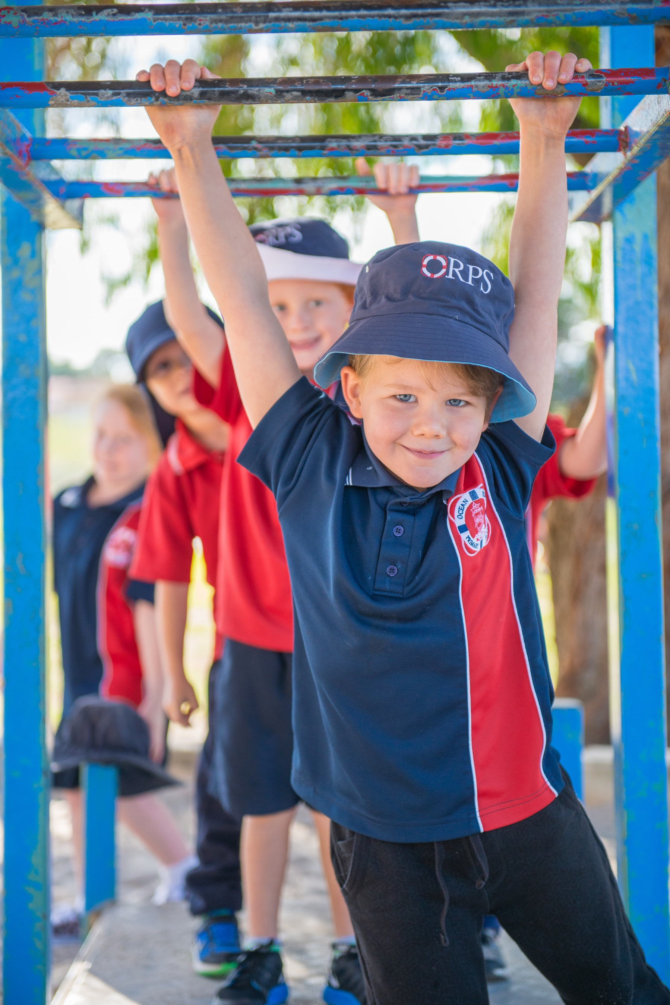
Sailor’s Manual 2017
Contents

Contents 2
Welcome to Ocean Reef Primary School 3
Important Contact Information 4
Our School Vision 5
Our Ethos and Culture 5
The School Day 6
Staffing 7
General Information 8
School Uniform 11
Communication Between Home and School 13
Contact with teaching staff 13
Attendance 14
Student Health 15
Student Roles 16
School Board 17
Ocean Reef Parents and Citizens Association 18
ORPS Language 20
Map of the School 21

Welcome to Ocean Reef Primary School
Thank you for choosing the State School Ship Ocean Reef for your journey through primary school.
We are a school with a proud tradition that began in 1988 with the establishment of a maritime theme by our founding principal Mr John Thompson. Mr Thompson took our location, metres from the Indian Ocean and the Ocean Reef Maritime precinct, as inspiration to model Ocean Reef Primary School as a virtual ship – the State School Ship Ocean Reef.
As a virtual ship, our school provides opportunities for teamwork, common directions, a sense of adventure and a journey ahead. Elements of the maritime theme are built into the physical environment of the school. A host of nautical terms describes school operations and school equipment. Flags are flown from a signal hoist, classrooms are called cabins and all crew, students (kindergarten to year seven), staff, parents and community members have a role to play in the daily operations of our ship.
A link to the Navy was an important part of the inspiration of the theme with the connections to discipline, pride and the pursuit of excellence in all that is achieved. We are acknowledged by the Royal Australian Navy as one of only two land based ships.
Since its inception the school has had a defined set of values. These are known as the ‘Seven Cs’. They are: Cooperation, Consideration, Courtesy, Common Sense, Care, Commitment and Courage. These values form the very core of the school. In 2015 a STAR was born, as we realigned our school expectations to reflect a positive view of the behaviours we expect from our crew. Being Sensible, Thoughtful, Achieving and Respectful in all aspects of ship life are vital to maintaining the health and wellbeing of our crew.
Although our ship was commissioned in the 20th Century it has endured a number of refits over time. In 2011 we became an Independent Public School and are now fully rigged as a technological vessel capable of meeting the challenges of educating our crew in the 21st Century.
On behalf of our crew I welcome you aboard and wish you fair sailing and a following sea.

Peter Blackwell
Commanding Officer
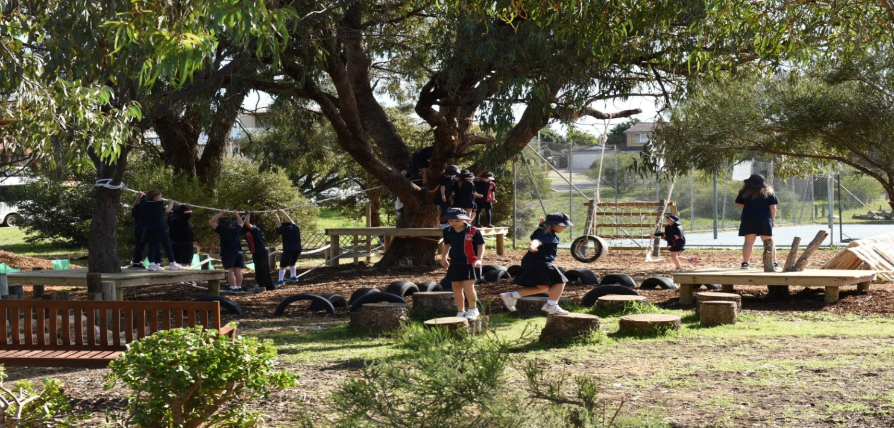

Important Contact Information
Ocean Reef Primary School
Kaufman Avenue
OCEAN REEF WA 6027

School Phone number: 9307 3444
School Email address: oceanreef.ps@education.wa.edu.au
Website: www.oceanreefps.wa.edu.au

SMS Absence Reporting: 0417 945 693

Principal: peter.blackwell@education.wa.edu.au
Associate Principal: christopher.smith@education.wa.edu.au
Registrar: sue.barr@education.wa.edu.au
School Officers: janelle.barnett@education.wa.edu.au
michele.green@education.wa.edu.au

Dental Surgery: 9307 4775 - Please note that the Dentist is a separate organisation that have a base on our site.

Ocean Reef P&C: orps.pandc@oceanreefps.wa.edu.au

If you see vandals at work please contact –
Education Security: 9264 4771 or 9264 4632
School Watch: 9264 4771
School Watch Mobile: 0417 939 985

Our School Vision
Ocean Reef Primary Schools vision is to provide an educational experience for each child that enables them to reach their full potential and equip them to adapt and succeed in their chosen endeavor in a continuously changing world.

Our Ethos and Culture
Since its inception the school has had a defining set of values. These are known as the Seven Cs.
They are…
- COOPERATION
- CONSIDERATION
- COURAGE
- COMMON SENSE
- CARE
- COMMITMENT
- COURAGE

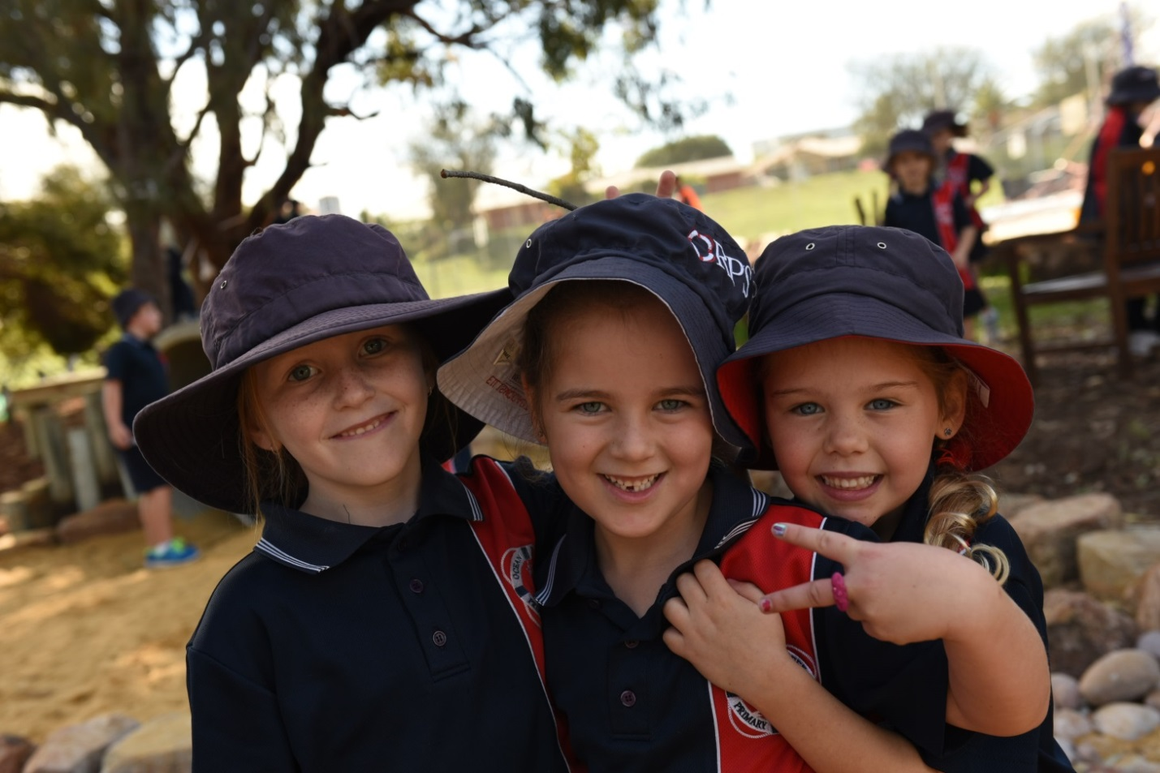

These values are at the very core of the school. If children leave school with a basic understanding of these seven values they will enhance their prospects in life. The Seven Cs are displayed throughout the school and form the basis of conduct by staff, students and parents.

The School Day

Term Dates
The term dates for Western Australian schools can be found at:
www.det.wa.edu.au/education/termdates/index.html:
The Department of Education provides details of current and future dates

School Hours
Children are asked NOT to arrive at school before 8.15am as adequate supervision cannot be provided. If circumstances require that children arrive at school before 8.15am, parents are asked to write a note to the school. Before 8.15am all children are required to go to the Chartroom.
The cabins are open from 8:30am and students are encouraged to spend some time getting ready for the school day with their class mates.

School Times

8:30am | In classroom, prepare for lesson start
8:44am | Siren to signal the start of the school day
10:40am | Recess
11:00am | Second session
12:40pm | Lunch
12:50pm | Commence lunch play
1:17pm | Prepare for third session
1:20pm | Third session
3:00pm | School ends (Monday, Tuesday, Thursday, Friday)
2.30pm | Every Wednesday (Early closure)

Staffing

The School
The school is led from the Bridge, by the Commanding Officer (Principal), Peter Blackwell. The ship is divided into an education centre, led by Associate Principal, Chris Smith and a business centre led by Sue Barr. The purpose of this organisational structure is to ensure a clear focus on The Classrooms First strategy. The school also has a Literacy Coordinator and Learning Support Coordinator.
The school employs a range of classroom teachers, specialist teachers in science, ICT, performing arts and physical education. Pre-primary and Kindergarten students have an educational assistant as well as other special educational needs assistants to support students throughout the school. In addition to this there are several ministerial support staff, librarians, cleaners and a gardener.

Students at Educational Risk
Students whose academic, social and/or emotional attributes are a barrier to engagement with the content and standards defined in the Western Australian Curriculum are defined as being ‘at risk’. At ORPS we also consider the progress that they are making or whether their attendance or punctuality is a barrier. The School’s SAER processes are managed by Alexis Rocca, the Learning Support Coordinator, our School Psychologist and Mark Walker our Chaplain. Many of the initial concerns are raised by the teaching staff but please contact the school if you have concerns yourself.
Some students may be able to access additional support as a result of their particular learning need, other adjustments will occur in the classroom. Many students will have a documented plan which is focused on personalising the learning for their specific needs.

School Psychologist
The school has access to a school psychologist, Helen McCagh. She can provide support in three main ways:
- Behaviour
- Working with students, parents and the school to identify and change target behaviour at the individual or group level.
- Learning
- Conduct assessments of students experiencing learning difficulties and/or disabilities at school.
- Support schools in making appropriate curriculum adjustments for students in order to enhance their learning outcomes.
- Mental Health and Wellbeing
- Provide direct support for students experiencing mental health and wellbeing difficulties.
- Assist schools and children to maximize the development of positive mental health and wellbeing

Recommendations or request for support from the school psychologist should go through the Associate Principal.

Chaplain
The school has been fortunate to obtain the services of a chaplain. Mark Walker is an experienced chaplain and plays an important role within the school community assisting us with our social and emotional needs.

General Information

Term calendar
Term calenders can be found on our web site. Should there be any date changes through out the year, this is where the most up to date calenders are published.

Public Holidays
There are 10 public holidays in WA, some of which fall during term time when the school will also be closed. The Department of Commerce website maintains an up to date list of public holidays: http://bit.ly/PublicHolidaysinWA

School Development Days
The school staff will be involved in Professional Development on several days during the course of the year. On these days students do not attend. Dates are on the Term Planner and are published regularly in the Tannoy.

Change of Address /Telephone
Throughout the year we often send out information via post or email. If you change your address, phone number or email address please would you let us know of these changes when they occur. The well-being of your child often depends upon us having accurate information.

Media Consent Form
From time to time the school will take photos of the students or their work to use on the school website, in our publications or to promote the work of the school. Included in our enrolment pack is a media consent form which we would ask you to complete if you are happy for your child’s images to be used. We will not use images without this consent.

Out of School Child Care Centre (OROOSH)
This facility for before and after school care is available at the school. If parents require any information please visit their website – oroosh.com.au or ring Helen on 0412 042 412.

Behaviour EDUCATION Policy
We have a whole school approach to classroom management and student care, built upon the Department of Educations ‘Classroom Management Strategies’ and our participation in the PBS, where expectations are
Our Classroom Management philosophy promotes a positive environment that will maximise student potential. The guiding principles of our philosophy are:
- Every child has the right to learn without disruption from others.
- Every teacher has the right to teach without the disruption from students.
- Students should be taught to accept responsibility for their own behaviour.
- Teachers work to establish a positive classroom and school environment.
- All people within the school environment should be courteous to each other and have respect for one another.
- All people within the school environment should take on the responsibility to establish and maintain a pleasant school environment.
- A consistent whole school approach to behaviour management exists throughout the school.
- Records are kept of children’s misbehaviour.

In 2015 a STAR was born as part of the PBS on school rules were replaced by positive expectations. Firm, consistent and appropriate consequences will be applied where behaviour is deemed as being unacceptable or where established school rules have been intentionally broken or ignored. Good behaviour is recognised and rewarded.

School Musters (Assemblies)
Every class in the school, with the exception of the Kindergarten students, presents one assembly per year. Musters are held at 8:45am on Thursday mornings and parents are very welcome to attend. The dates of cabin musters are published in the Tannoy and Calendars
Children are presented with commendation awards at the muster. If your child is to receive an award you will receive a text message inviting you to attend. The awards are presented at the beginning and you may choose to leave straight afterwards if you have another commitment.

Bicycles, Scooters and Skateboards
Bicycle racks are provided for the children’s bikes. The bike rack area is locked during school time. Children must wear helmets and bikes must be in good order. In accordance with child safety and police advice, children riding to school should not be under the age of 10. Children are prohibited from riding bicycles in the school grounds. Scooters and skateboards should be kept in this area too, not in blocks.

Dogs and Other Animals
In accordance with Regulation 77 of the School Education Regulations 2000, dogs and other animals are not allowed on the school site at any point. Service dogs (guide dogs) are exempt from this regulation.

Money At School
All payments for collection by the school should be taken to the red boxes in the Bridge. Envelopes should have the student’s name, cabin and the name of the incursion/excursion on them. Payments can also be made via EFTPOS at the Bridge or by direct payment

Account Name: Ocean Reef Primary School
BSB Number: 066-166
Account Number: 00900276

When paying by cheque please make payable to ‘Ocean Reef Primary School’. Loose money should not be sent in your child’s bag.

Parents Wishing to Help
Parent help is encouraged throughout the school. If you’d like to assist please
- contact your child’s teacher
- contact the Bridge
- contact the library officer
- contact the P&C – The P&C (based in Cabin 10) is also open on Friday before school. Kat Backhouse, P&C President can be contacted via orps.pandc@oceanreefps.wa.edu.au
- All parent helpers must sign in at the Bridge.

Road Safety, Car Park and Children
Car parks cause us much concern, especially on rainy days when visibility is poor. When delivering and/or picking up children from school, please ensure that children do not cross the road by themselves and that they use the cross-walk and the services of the attendant.
The ‘Kiss and Drive’ parking bays on Venturi Drive are for drop-off of children only. Drivers should not leave their cars when using ‘Kiss and Drive’ bays. If you wish to leave your car please park outside of these areas.

School Voluntary Contribution
The School Education Act 1999 allows schools to request a voluntary contribution (With a maximum amount of $60.00) per student from parents and carers. The school board has endorsed the voluntary contributions being set at $60.00 per student. Your $60.00 school voluntary contribution is used to assist with the cost of resources including consumable items within our school. The voluntary contributions are used to support all learning areas to purchase shared items such as paint, science material, technology and enterprise consumables, maths activities and reading resources for English. Without these voluntary contributions we are restricted in the breadth and depth of the curriculum programs we can offer in our school. The contributions can be paid at the Bridge.

Interm Swimming
Once a year Pre-primary to Year 6 students have the opportunity for a fortnight’s swimming lessons at the HBF Arena, Joondalup. This year they will happen from August 15 to August 26. The time of year rotates, one year in the summer and the next in the winter. The cost for the lessons covers entry to the pool and transportation for the two weeks and is normally in the region of $45. Spectators are welcome but an entry fee is charged by the Arena.

Excursions and Incursions
From time to time the school offers a program of excursions and visits of educational interest. These are an important part of a student’s education and it is hoped that all those who are invited will be able to participate. A letter is sent out in advance providing details of the event and costs. As a general rule forms and money will normally be due about a week in advance and should be returned to the boxes in the Bridge, not your child’s teacher.

School Canteen
The school does not have a Canteen. On occasion, the P&C run a special lunch event. Details are provided prior to the event.

Mobile Phones
Mobile phones and other electronic devices such as iPods, toys, games etc should not be brought to school. If they are used as part of a reward then a process is put in place to keep them secure during the day.

learning An Instrument
In Year 6, 15 students are given the opportunity to learn classical guitar or a brass instrument. The lessons are taught by the school of instrumental music and they provide criteria for selection. The weekly lessons are free but there is a charge to hire an instrument and a commitment to learning is required.

Information Communication Technology use at School
The school has access to excellent ICT resources with quality networked computers, interactive whiteboards and ipads to assist students and staff with their learning. All computers and devices within the school have internet access.
The parents and students at ORPS are advised that the Department of Education has a mandatory ‘Students’ Online’ policy which governs all computer usage on our school premises.
This means that through the Department, ORPS will make every reasonable effort to provide safe and secure online learning experiences for students when using the Department’s services. Parents and students are required to complete an Acceptable User Policy form when enrolling and at other times throughout their school career.

Marking of Clothes and Belongings & Lost Property
All articles of clothing should be marked with your child’s name. An amazing amount of clothing is lost every term. Lost clothing is collected and returned to student’s cabin as long as it is named. Unnamed lost property is placed into a bucket outside of the back door of the Bridge and can be searched for here. Please do not go into Cabin 10 looking for lost property. Anything unnamed and unclaimed will be sold from the P&C shop in Cabin 10.

Parenting Plans, Family Court Orders and Other Orders
Please let us know if there are any legal restrictions in place for your child. All details are treated in the strictest confidence.

Homework
We believe that homework should support student learning and provide the opportunity for students to practice basic skills that will enhance their learning. In addition to this, homework should complement family life and allow children to develop their social, physical and oral language skills. As a school we do not provide specific homework tasks on a regular basis.
The SURFS home reading program and the early years reading strategy documents should be used as well as basic number facts based on addition, subtraction, multiplication, division as well as currency.
Your teacher may also implement some intervention strategies for you to complete at home when appropriate.

SURFS
The SURFS (Sustained Uninterrupted Reading For Success) home reading programme is run through the Chartroom. The purpose of the program is to promote a love of reading and improve children’s comprehension. Children are tested at various stages throughout the year and given a SURFS (or Lexile) score. In the Chartroom books are labeled to reflect the SURFS score with a colour sticker. Children can borrow books from this category and then complete an online quiz. The more quizzes that are completed the more success the students achieve.

The Chartroom is open most days before school, from 8:15, and at recess and lunchtime. Children can also change their books during their normal Chartroom session during the week.

School Uniform
The School Board of Ocean Reef Primary School has established a dress code for all students attending the school. The School Board believes a school dress code:
- Fosters and enhances the public image of the school;
- Assists in building school and team spirit;
- Ensures students are safely dressed for specific school activities;
- Encourages equity among students.

Dress Code Requirements
At the start of 2015 ORPS changed its uniform shirts to a blue based uniform. This shirt and associated jumpers are all available from the Uniform Concept Shop, 5/7 Delage Street, Joondalup.
Pricelist is our our website for your information.

Pre-primary upwards
Students should wear the blue polo shirt with school logo, red polo shirt for Kindy students available from the uniform shop. Sailor style dresses for girls who are pre-primary upwards are also part of the uniform.
Pant/shirt options include:
- Navy pleated sports skirt worn with either navy sports brief or navy bike pants as undergarments or Navy skort, navy shorts
- Navy Shorts – (no football shorts, brief shorts or board shorts) to be worn with any of above mentioned shirt/t-shirt options.
- Navy blue micro-fibre wind-proof jacket with logo
- Navy track pants or navy full length pants (not jeans)
- Micro-fibre navy track pants

Footwear
All students should wear appropriate footwear. Acceptable options are joggers, closed in shoes and flat sandals. Footwear is to be predominately white or predominately black. Unacceptable items of footwear include thongs, surf sandals, any shoe with an elevated heel, massage sandals, ugg boots and any backless shoes are not allowed.

Hats
The school has a ‘No hat no play’ policy for the oval. Navy broad brimmed hats, school bucket or legionnaires hat are the only acceptable hats. School bucket hats with reversible ship colours are available from the uniform shop.
Jewellery
In the interest of student safety, jewellery should be kept to a minimum. No costume or fashion jewellery is acceptable. Plain sleepers or studs are acceptable earrings.

Makeup
Makeup is not acceptable for any student. Nail varnish should not be worn at school.

Hair
Hair longer than collar length must be tied back to aid in the prevention of head lice.

Sunscreen
Sunscreen should be applied prior to the start of school. Children are also encouraged to reapply their own sunscreen before recess and lunchtime. As such, all children should carry their own supply of sunscreen.

Sports Carnivals and Other Ship Events
On carnival days students can wear t-shirts that represent the colour of their ship, there is no specific shirt that should be worn. If you are in Phillip then you can wear any red t-shirt, Stirling a white t-shirt and Dampier, a light blue t-shirt. Students are assigned ships when they enrol and will remain in the same ship during their time at Ocean Reef Primary Primary.

Stirling Phillip Dampier

Communication Between Home and School

Newsletter – The Tannoy
Once a fortnight the school publishes ‘The Tannoy’ and distributes it on a Thursday to parents via email. The Tannoy provides a wide variety of information concerning school programs and activities. Hard copies are available on request from the Bridge.
The Tannoy is a vital link between the school and home and parents should make sure that they read it carefully. The Tannoy is also available on the school website: www.oceanreefps.wa.edu.au

Website & School Facebook Page
Our website and Facebook is currently being updated and we hope to have it fully functional in 2017.

The Lighthouse & SMS
Sometimes we have to get information to you quickly, on these occasions we may use an emailed note, the Lighthouse or an SMS to your phone.

Visiting the School During the Day
If you need to come to the school during the day, outside of normal drop off and pick up times, please go to the main administration block, The Bridge, first to sign in. This helps us with making the site as secure as possible and in case of emergency.

Contact with Teaching Staff

Concerns
Parents with concerns to discuss with teaching staff are requested to phone the school on 9307 3444, write a letter or email oceanreef.ps@education.wa.edu.au to arrange a mutually agreeable meeting time.
Every teacher has time set aside each week to use for duties other than teaching (DOTT). If you wish to have a talk to a teacher please find out when the teacher is free and arrange the discussion to occur during that, or other suitable time.
If you wish to meet with the Principal or Associate Principal, please contact the Bridge to make an appointment.

Resolving Issues and Concerns
Ocean Reef Primary School aims to create a school culture that welcomes, encourages and initiates regular two-way school-home communication. It is recognised that caring parent and teachers want ‘the best’ for children and therefore issues and concerns can arise. Clearly defined resolution processes facilitate parents and school personnel to focus on early resolutions to issues and concerns in order to foster and support children’s academic progress, their physical development and social and emotional well-being.

Attendance

Everyday Matters
In order to access the full curriculum, and give your child the best chance of success, the school aims to support and encourage children to set an attendance goal that is as close to 100% as possible.
The below chart gives a breakdown of how the amount of time missed in a year, and if maintained across their schooling can impacts on the future education of your child.
Period of Absence (PP – Y10) | Rate of Attendance | Equivalent amount of School Missed if the Percentage Rate in Maintained between PP-Y10
0 – 2.5 days missed per term | 95% - 100% | 0 -6 months
Average of 5 days missed per term | 90% - 95% | 1 Year
1 day missed per week | 80% - 89% | 2 Years
1.5 days missed per week | 70% - 79% | 3 Years
2 days missed per week | 60% - 69% | 4 Years
2.5 days missed per week | 50% - 59% | 5 Years
3 days missed per week | 40% - 49% | 6 Years

Reporting Absence
Please contact the school if your child is going to be away or is ill. Although the Bridge doesn’t open until 8:15 a message can be left on the answerphone – The number is 9307 3444 or an email sent to oceanreef.ps@education.wa.edu.au
You may also receive a SMS message after 10:00am enquiring about your child’s absence. A reply to this text message to explain your child’s absence will also suffice. You can report absence via SMS on 0417 945 693.
As a part of our school processes you may, if absences are still unexplained, receive letters from us. We would be grateful if you would use any of the methods above to inform us.

Holidays
If you plan to take your child out of school for a holiday during term time, please discuss with the Principal. School work for this time will not be provided but we would strongly promote keeping a journal, either in paper or digitally, setting up a blog that can be linked back to the class, plenty of reading books and practice of basic number facts, addition, subtraction, multiplication, etc and practice with currency.

Need to pick up your child during the day?
Children are not permitted to leave the school grounds on their own. When picking up a child/ren from school during school hours it will be necessary to obtain an Educational Department Leave Pass from the Bridge first.

Lateness
If you are late to school for any reason please go via the Bridge to obtain a late note. This allows us to know exactly who is on site at any point; a health and safety matter.

Student Health
The school has a nurse who visits the school on a regular basis. The main role of the nurse is health promotion and monitoring the health status of children. Teachers and parents have access to the nurse through a referral process.
If you wish your child to be seen by the community nurse at school you must complete the health record card, sign your consent to examination and return the card to school. On completion of primary school this record will be returned to you.
With parent consent a school based community nurse will carry out a full health appraisal for all four-year-olds, sometime during the course of each year. This will include:
- vision screening
- hearing screening
- assessment of co-ordination, posture and gait
- examination of skin and mouth
- measure of height and weight.
If any concerns are identified during the course of the appraisal, parents will be notified. Appropriate action is then jointly decided and acted upon through arranging a visit to the family doctor, community and child health medical officer, child development team or other appropriate agency.
Parents are encouraged to contact the community nurse at any time during school year to discuss any concerns regarding their child’s health.

Immunisation
The close contact between children at school puts them at risk of contacting contagious diseases. On enrolment to the school parents will be asked to show their child’s immunisation record because immunisation provides the best possible protection available against childhood diseases.

Sickness
The school does not have adequate facilities for children who take ill during the day. The school must have current information so that parents can be contacted quickly and efficiently. Children who are just feeling ‘under the weather’ will be sent back to class until you are able to collect them.

Head Lice (Nits)
From time to time every school has a problem with Head Lice. The policy of the school is that a child with head lice will be excluded from school until treatment has commenced. Family contacts will not be excluded, though it would be advisable for all to have the treatment as they will probably be infected.
Head lice can only be caught by head to head contact. Head lice do not jump, fly or swim. Any lice found on chairs, clothing or bedding are usually injured or dying and would be incapable of climbing onto another host. Any hair longer than shoulder length must be tied up.

Communicable Diseases
Sometimes it is better for sick children to be kept at home. This document outlines when this is appropriate and is the basis of decisions made by DoEWA schools.

Medical Emergency
Ambulance
As we do not have access to trained medical expertise on site, in the event of a serious accident where parents cannot be contacted, an ambulance will be called at parent’s expense.

Medical/Health Conditions
Please ensure that these are listed on the Admission Card, and that this information is kept up to date. Some conditions such as asthma, diabetes, epilepsy or allergies require a detailed health management plan which will be developed in consultation with parents and your doctor. We require information in regard to developmental concerns, communication skills, gross or fine motor deficiencies or lack of socially acceptable behaviour. This may assist us in accessing resources to assist your child.

Medicines
If your son or daughter requires a medicine during the day, even over a short period of time, it should be given to the Bridge. There is a small amount of paper work that we need to complete so that we can make sure the correct doses are given.

Ocean Reef Dental Therapy Centre
Although not managed by the school, there is a dental therapy centre based on the school site. The children are normally seen at least once a year. The centre can be contacted be contacted on 9307 4775.

Emergency Contact Number
Parents are requested to make sure that the emergency address, phone numbers and email addressed registered on their child’s enrolment forms are up to date. This helps avoid unnecessary delays in contacting parents.

Food Allergies
We have several students who have severe food allergies. This is a growing issue for many schools, as the incidence of food allergies in the general community has increased significantly over the last few years. It is important for us to have a shared sense of duty of care.
As a school, we can minimize the risk by ensuring that:
- Students do not share food, utensils or food containers
- Students with allergies only eat food that is prepared at their own home
- All food and drinks containers are clearly labeled with student’ names to avoid confusion of ownership.
- Make the teacher aware if you send in any birthday cakes, etc. to share around the class.
If your child does react, please make sure that we have a copy of their emergency plan.

Student Roles

Junior Officers
Children in Year Six are nominated and elected by their peers for leadership positions. Because of our nautical theme these leaders are given certain ranks associated with the navy. The highest rank that can be achieved by a Year Six is the rank of Captain. Captains and Commanders are the equivalent of school prefects. Lieutenants are the equivalent sport leaders. Official announcement of our student leaders, including the presentation of their badges, occurs in term 4 of the preceeding year. Chosen students are expected to provide leadership and to set the highest possible standard of endeavour and behaviour.

Drum Corps (Pronounced “Core”)
In Years 5 & 6 students have the opportunity to join the Corps. This group meet every Wednesday at 7:45 in the studio and then for flag practice on Thursday Morning at 8:15 in the Quarterdeck. Over the past few years the Corps have performed in Fremantle at the Celebrate Maritime Day, the Royal Show and represent the Navy.

School Board
As an Independent Public School, Ocean Reef Primary School is required to have an effective School Board that includes community, business & industry representation. The past School Council model has been reformed as the Ocean Reef Primary School Board from 2011 with established protocols, procedures and Terms of Reference, in accordance with the Education Act 1999. Elections for Board members are called annually, as positions become vacant. These have been staggered to ensure continuity, so only half will be up for election each year. The Board Chair is elected by the School Board for a term of two years.
As Chief Executive Officer, the Principal is directly responsible to the board for the educational leadership, development, operation and management of the school. The Role of the School Board is to enhance and provide support, direction and community input into school development, policy and the Delivery and Performance Agreement. The Principal reports to, seeks advice and gains ratification from the School Board on strategic matters regularly (at least once per term). Each year, the Principal will provide a whole school report to the School Board on progress against the Ocean Reef Primary School Strategic and Business Plans, along with proposed action plans to address identified needs and review changes to the Plan.
About the School Board
The Board has been formed with the fundamental purpose of enabling parents and members of the community to engage in activities that are in the best interests of students and will enhance the education provided by the school.
There are clearly defined roles for the School Board but they are not responsible for operational matters of the day to day running of the school. More details of the Board’s functions are available on our website. http://bit.ly/ORPSBoard
What Can You Bring to the Board?
Parent members - bring their experience as parents at the school and the views and context of the wider school community to School Board meetings;
Community members - bring wider perspectives, particular skills and expertise to the School Board. They may have business, IT, accounting, building, or other skills that the school is looking for at that time; and
School Staff - bring their educational expertise and years of experience to School Board meetings.
STRUCTURE OF THE SCHOOL BOARD
The composition of the School Board reflects the diversity of the school community, strategic planning and development goals. Elected and coopted members will need to have the skills and experience required to provide sound governance and informed decision making in meeting the requirements of the Delivery and Performance Agreement.
Previous experience on a School Council is not essential; however a commitment to the position and the responsibility is essential. The success of the school relies on a successful School Board.

Ocean Reef Parents and Citizens Association
The P&C is made up of members of the community with an interest in our school. Generally the members are parents of children who attend the school.
The objectives of the P&C are to:
- promote the interest and the moral, physical, health, social and educational welfare of the children attending the school
- endeavour to bring about cooperation between the parents or guardians of the children attending the school, other citizens, teachers and children and to foster community interest in educational matters.
One of the main ways that the P&C attains its objectives is through major fundraising activities, such as fairs, quiz nights and other social/fundraising activities.
The P&C contributes a substantial amount of money each year. Funds are used to upgrade the facilities and improve the learning environment of the school. Their money has been used to help with security, air conditioning, computing, reading material, chartroom requirements and the school grounds.
Currently, the annual subscription to join the P&C is $1.00. Only financial members are permitted to vote.
The P&C meet twice a term in the staffroom on Wednesdays 7pm in weeks 3 and 7. Meetings normally finish by 8:30. At the March meeting the new executive of the P&C is elected. The P&C Room, Cabin 10 is open on Friday mornings for banking, lost property and a coffee.

The Pirates
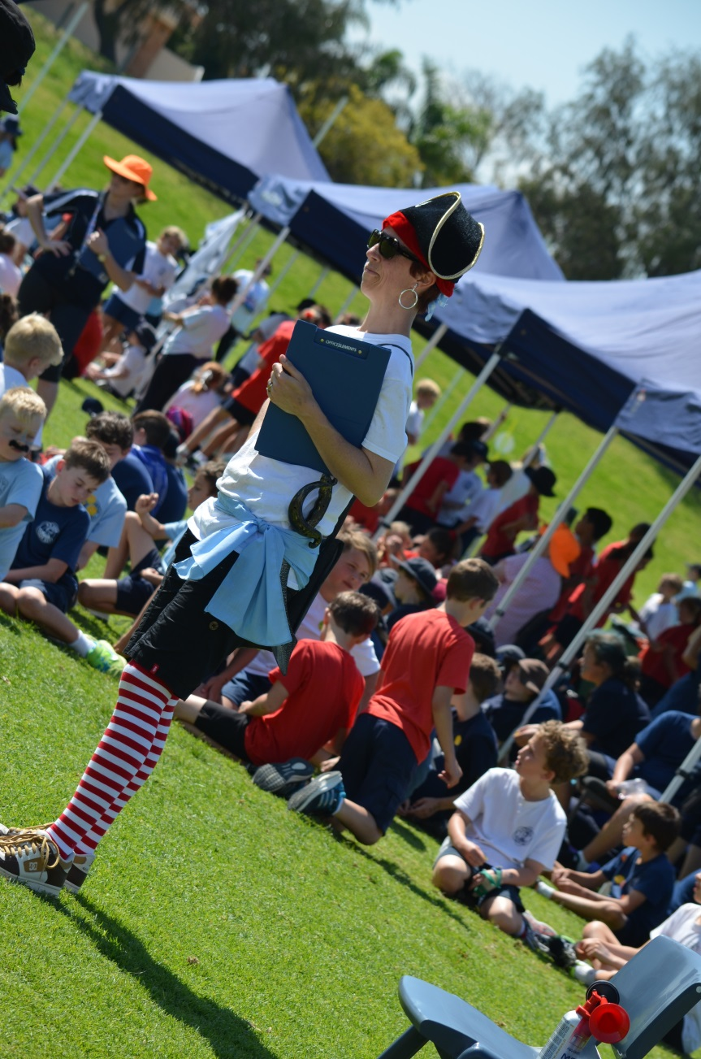
In 2013 the school community committed to improve their support of our ship with the evolution of the ‘Pirates’. The pirates are a sub-group of the P&C and were formed by the parent body, creating a new feature and focus for community support of our school. They play a really important role in helping to create ‘fun’ within the school.

Brand New to the School?
When you join a new school it is sometimes difficult to get to know other families. The P&C are keen to get to know you. Please fill in the new families form in the enrolment pack if you would like a member of the school community to contact you.

Voluntary P&C Contribution
We know that other commitments mean that we do not always have the time to support the P&C on a regular basis and the P&C voluntary contribution is a way that some of you may choose to help.
Over the past few years, through your voluntary contributions and P&C fundraising the school has been able to purchase many extra items to support our learning environment. For example, the P&C’s efforts have purchased over 60 ipads, the charging station, security trolley and assisted in the funding the professional learning for staff. The Voluntary Contribution can be paid through the personal items list (Booklist) or directly at the Bridge.

School Banking
Students have the opportunity to develop a saving career with the Commonwealth Bank of Australia. Money can be deposited through the P&C on a Friday morning in Cabin 10. More information is available.
The P&C President is Kat Backhouse and she can be contacted via orps.pandc@oceanreefps.wa.edu.au
The P&C Room is open every Friday morning until 10am.

ORPS Language
Due to our maritime and naval traditions we often use a unique language at ORPS. Here are a few of the more regularly used ones.
Commanding Officer | Principal
Crew | Staff
Junior Crew | Students
Bridge | The main administration building
Junior Officers – Commanders, Lieutenants and Warrant Officers | Student leaders
Chartroom | The library
Cabins | Classrooms
Quarterdeck | The main undercover meeting hall for the students
Galley | Canteen
Ships | Our school factions – Stirling, Cook & Phillip
Tannoy | Our fortnightly newsletter
Lighthouse | An email that is sent out by the Bridge (blue) or P&C (red) to update parents on a school matter that is more urgent than waiting for the Tannoy.
Drake’s Crew | Year 5 & 6 students who act as peer moderators at recess and lunchtime. They are identified by the yellow hi-visibility jackets.

Map of the School
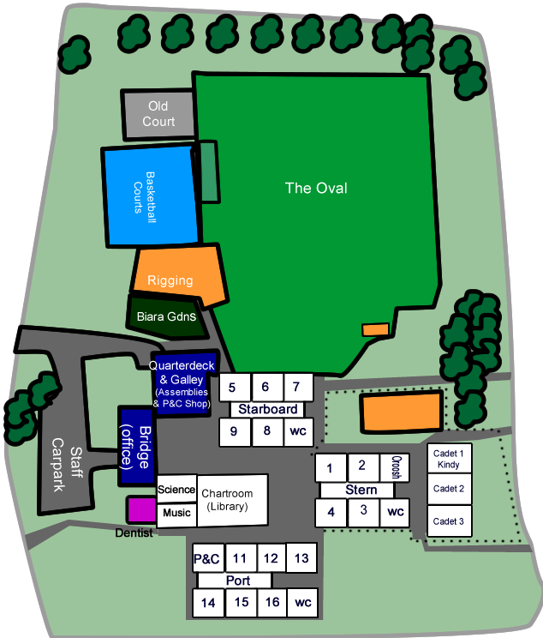

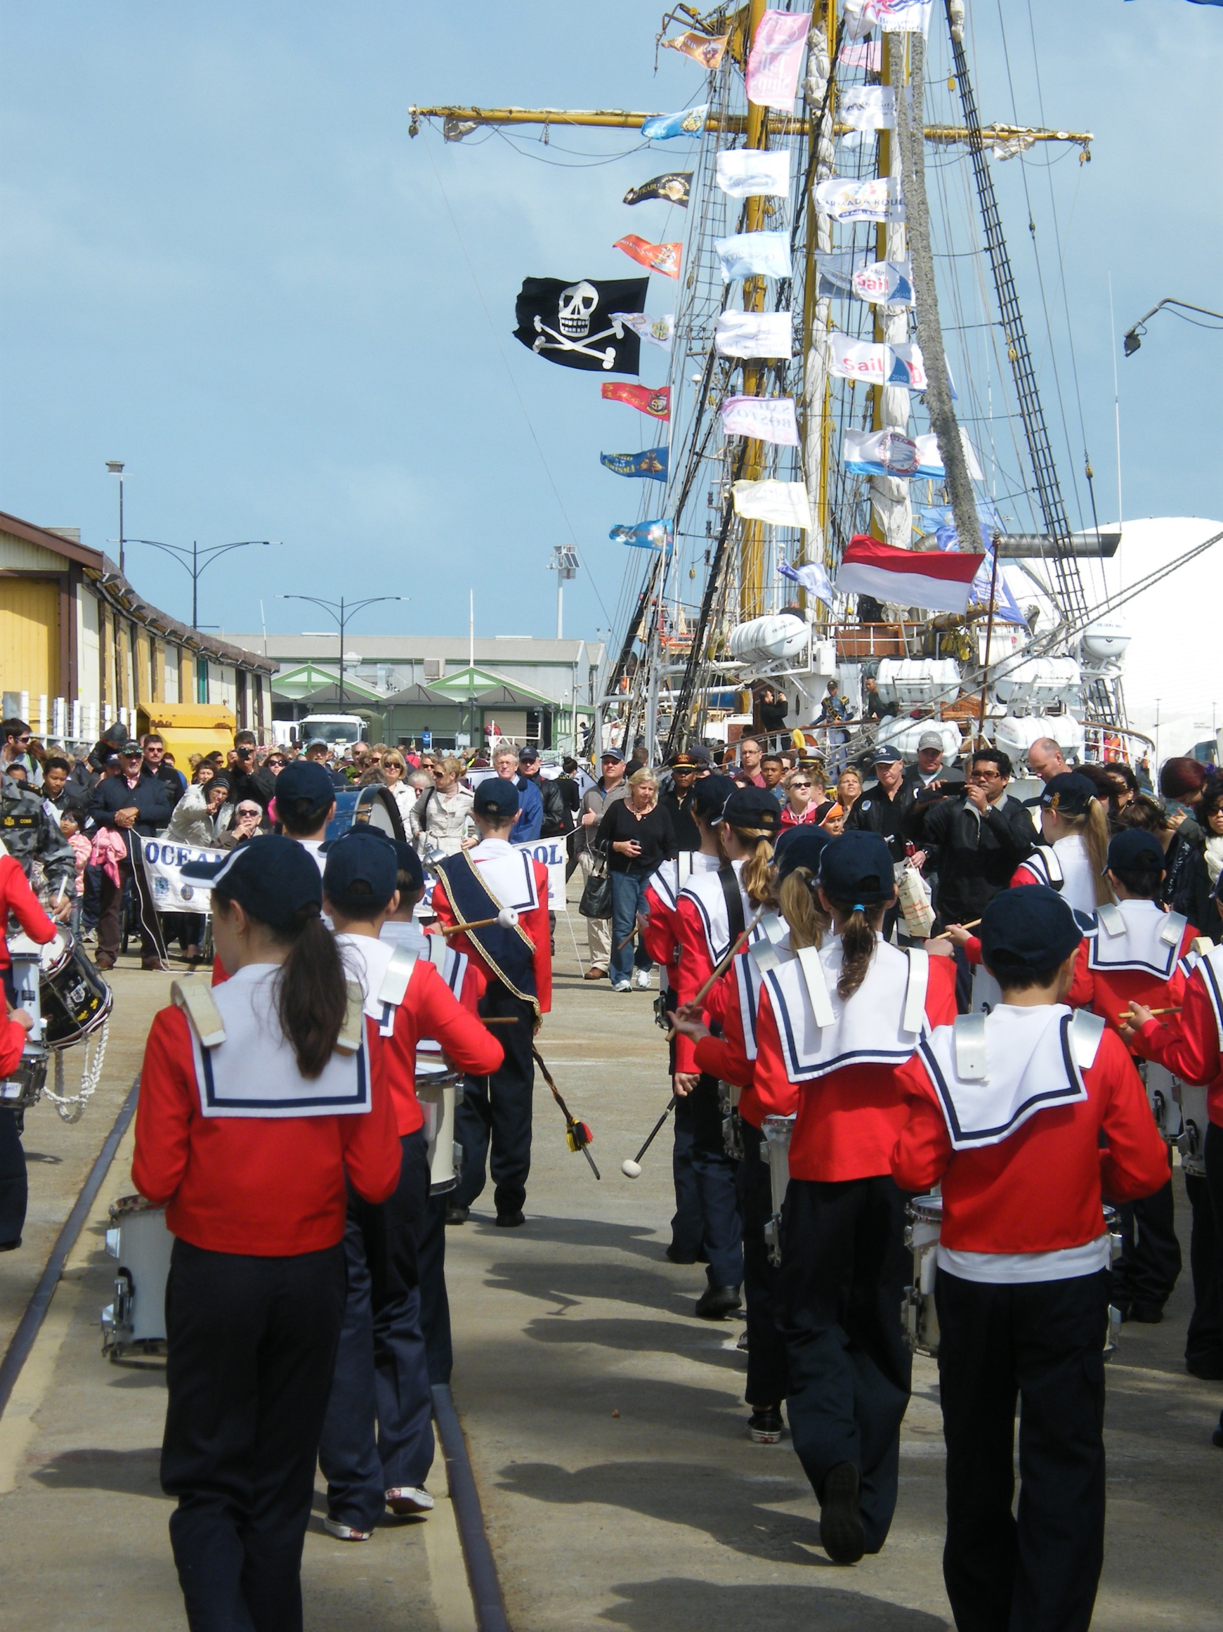
S:\AdminShared\Administration Staff\200 Community Relations\209 Community Relations Publications\Parent Information Booklets\Sailors Manual

